SES — Simple Email Service

Objectives
- Navigate Amazon SES: Access the Identities section inside the Amazon SES console on AWS and understand the interface layout.
- Create an Email Identity: Register an email address as a verified sender identity within Amazon SES so it can be used to send emails.
- Verify the Email Address: Complete the AWS email verification process by clicking the confirmation link sent to the registered inbox.
- Send a Test Email: Use the SES mailbox simulator to send a test email and explore different sending scenarios (e.g., Complaint, Bounce, Delivery).
- Confirm Successful Setup: Confirm that the identity status shows Verified and the test email was delivered successfully via the SES console.

Step-by-Step Guide
STEP 1 Open Amazon SES — Identities
Log in to the AWS Management Console and search for SES. In the left navigation panel, expand Configuration and click on Identities.
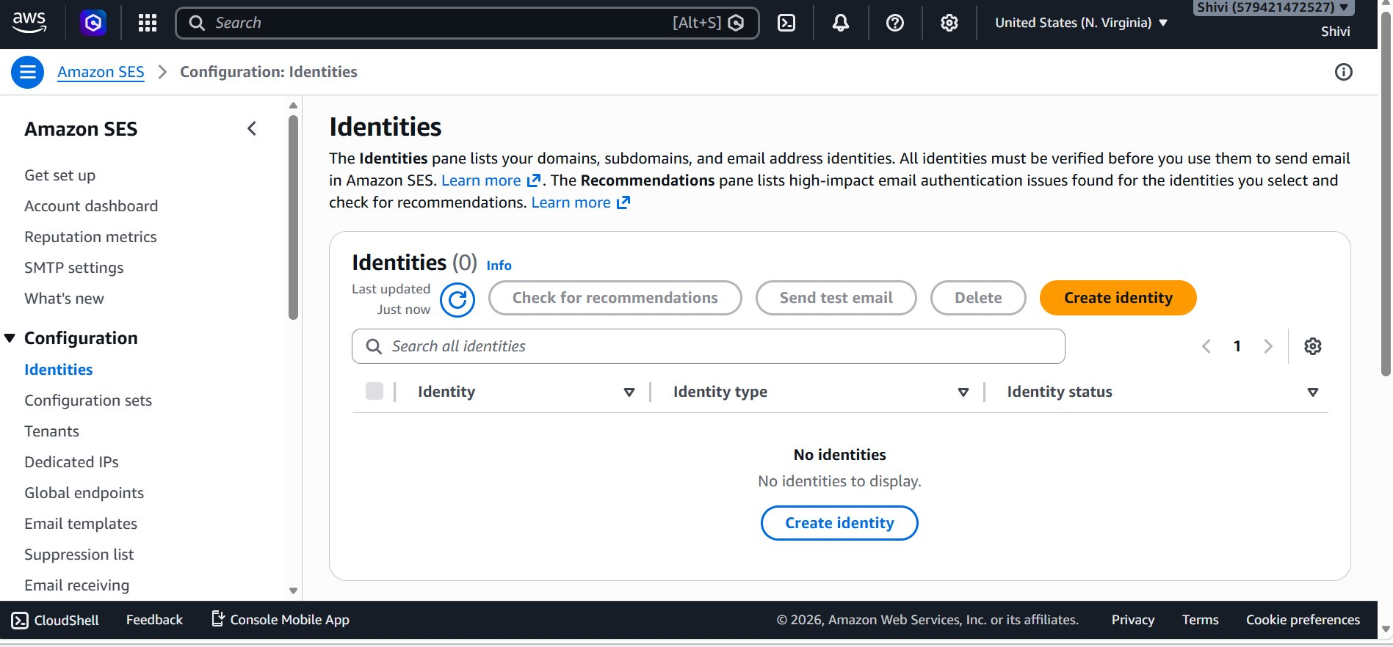
- Action: Click the orange Create identity button to proceed.

STEP 2 Create a New Email Identity
On the Create identity page, choose Email address as the identity type. Enter the email address you wish to use as a sender — here studypower2022@gmail.com is used. Scroll down and click Create identity to submit.
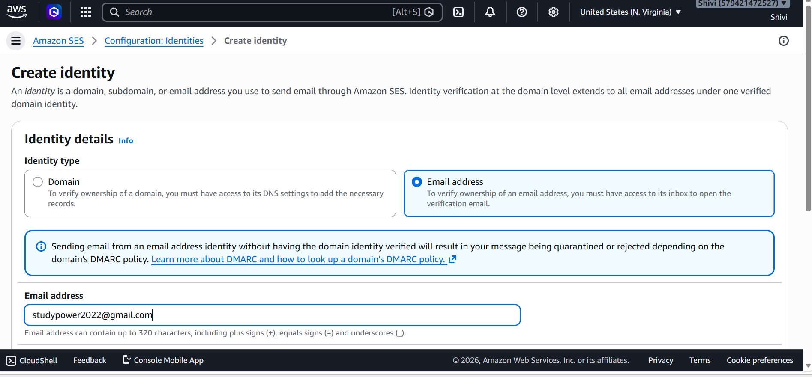
- Identity type — Email address
- Email entered: studypower2022@gmail.com

STEP 3 Verify the Email Address
After creating the identity, Amazon SES sends a verification email to the address you entered. Open the inbox of that email address, find the email from Amazon Web Services, and click the verification link inside it. The browser then redirects to the Confirmation page shown below.
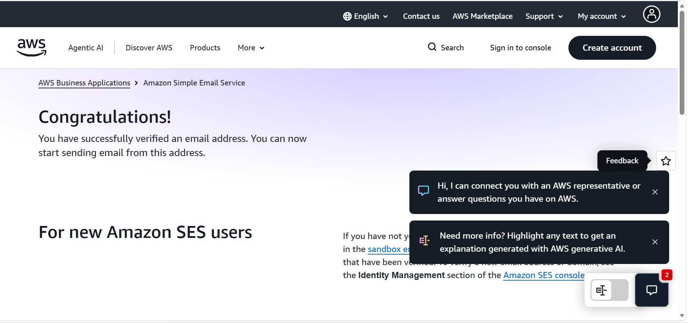

STEP 4 Send a Test Email
Return to the SES console, select the verified identity, and click Send test email. Choose Formatted as the email format. Under Scenario, select Complaint (or another scenario) which auto-fills a simulator recipient. Enter a Subject and optional Body, then send.
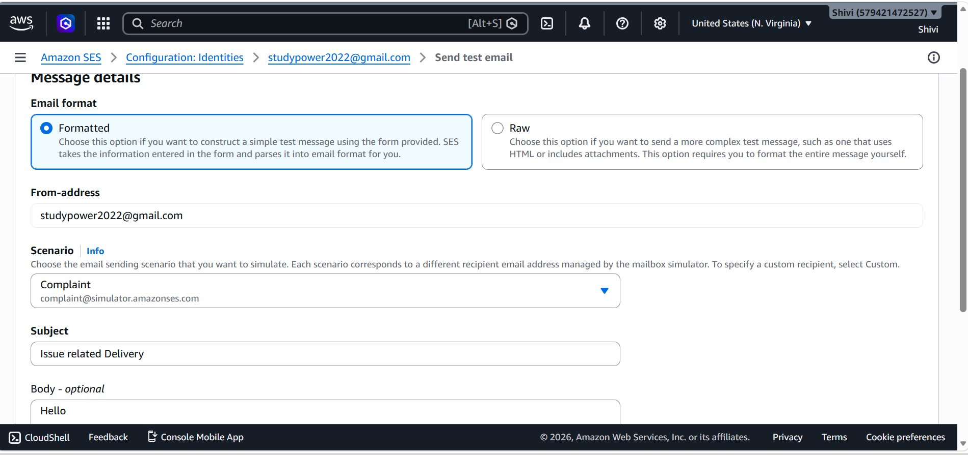

STEP 5 Confirm Successful Verification & Test
After sending the test email, you are redirected back to the Identities list. A green success banner appears at the top of the page. The identity studypower2022@gmail.com is now listed with Identity status: Verified, indicated by a green checkmark.
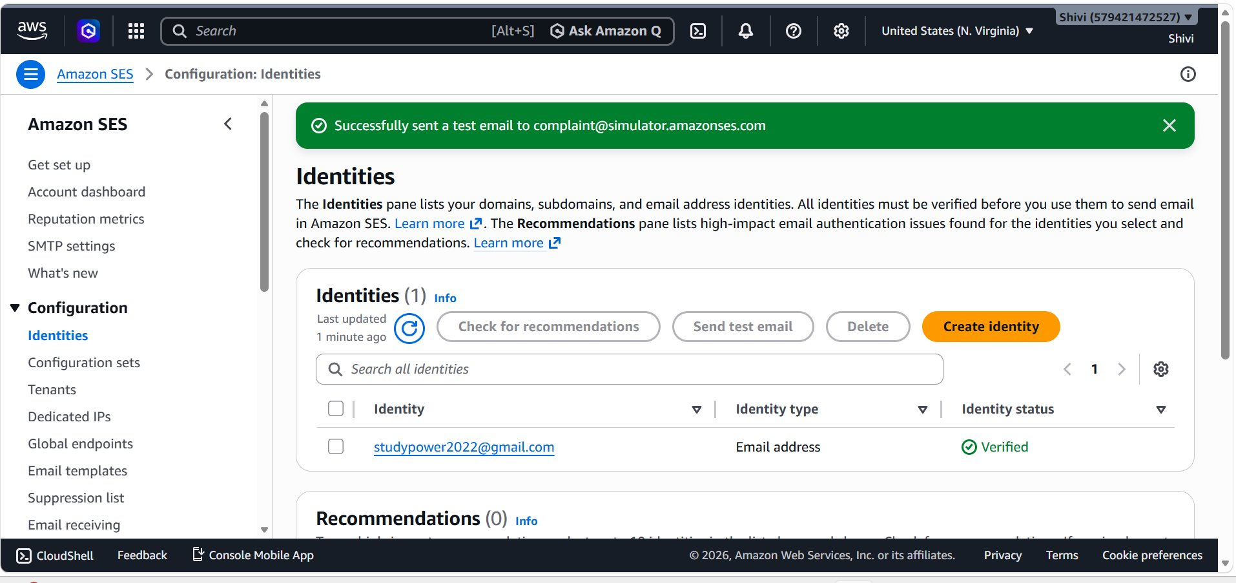
- Green banner: Successfully sent a test email to complaint@simulator.amazonses.com.
- Identity status: Verified (green checkmark icon)
- You can now use this verified identity to send emails through Amazon SES.

